**Exercise 4: Functions**

Scenario 1: Calculate the age of customers for eligibility checks.

**PL/SQL Code:**

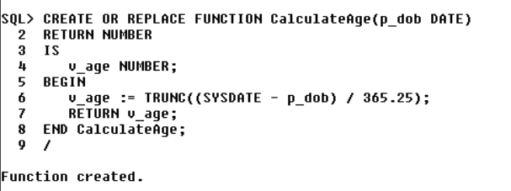

**Output:**

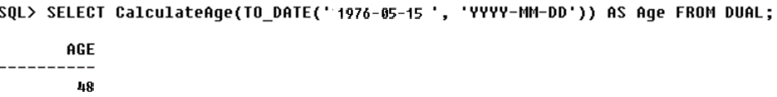

Scenario 2: The bank needs to compute the monthly installment for a loan.

**PL/SQL Code:**

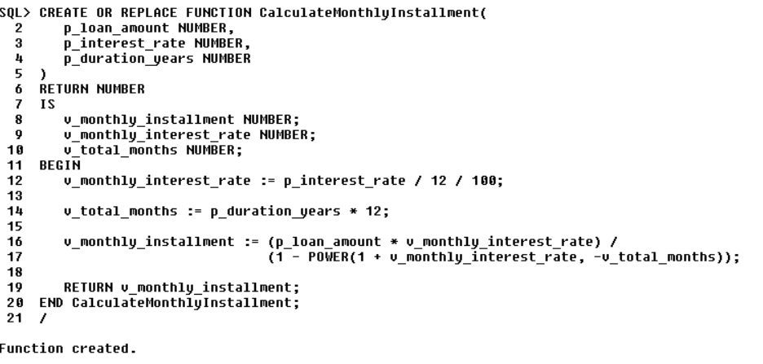

**Output:**

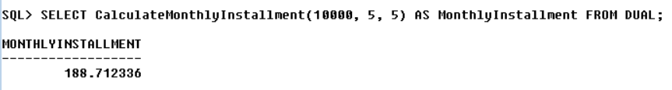

Scenario 3: Check if a customer has sufficient balance before making a transaction.

**PL/SQL Code:**

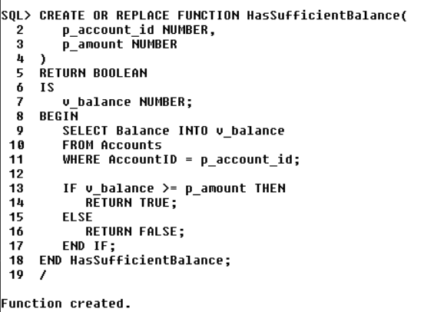

**Output:**

